**Mobile Game Application Analysis: Final Report**

Group 2A

Geoffrey Nel, Aneesh Kalaga

Arpita Sharada, Shuochen Xu, Anuja Dixit

**Abstract**

The traditional gaming industry—from the 1990’s until the 2010’s—is cemented in the pc and console gaming world; however, as we now enter into a new decade, there are significant signs of change as we witness the rise of a dominant new platform. This platform has come about through the proliferation of mobile devices, where consumers can access applications, or more notably games, from anywhere. This ease of access along with low cost of applications has aided the spread of mobile gaming. For these reasons, along with the proportional financial impact that the gaming industry now having on the economy, is why we have decided to base our analysis in this area. In our analysis we will be using data derived from one of the two major application stores, the Apple IOS store, where we will analyze features in respect to their impact on the application ratings. We note that ratings are an important measure for users in how they initially view the application. Our analysis will focus on four main variables in respect to rating, such as application price, age rating, language, and app update frequency. After converting the rating to a binary variable, we will analyze the implications of these variables on whether they implicate ratings being good or bad. We will finalize with propensity score matching on apps that have been developed in multiple languages and apps that have received updates within a 1 year period.

**Table of Contents**

**Introduction.** **3**

**Data & EDA** **5**

Initial EDA 6

Descriptive statistics before data cleaning: 6

Analysing Missing Values in Variables: 7

Extracting Icons for games on App store: 7

Average User Rating Count: 8

Correlation Plot for Genre List: 8

Correlation Network Plot for Genre: 9

Size and Average_User_Rating Analysis: 9

Size and Original_Release_Date Analysis: 10

App Price Analysis: 10

App Age-Rating Analysis: 11

Top 10 Languages: 11

Most Reviewed & Popular Games: 12

Best Overall Game in App Store 12

Wordcloud of Name: 13

Data Cleaning, Manipulation & Post EDA 14

**Modelling** **16**

Premodeling 16

Propensity & Logistic Regression 17

Propensity Score Matching - Multiple Languages 17

Propensity Score Matching - 1- Year Updates 20

**Conclusion** **24**

**Dataset Overview** **25**

**Additional Figures and Results** **26**

# **Introduction.**

It can be said that mobile gaming has historically been treated as the little brother of more well-known platforms like PC, Xbox, PlayStation, and Nintendo (Fig. xx). A decade ago, it would have been difficult to envision a gaming industry without these platforms placed staunchly at center stage, yet as the years have progressed, it is apparent now that mobile gaming has matured, now presumably taking the role of big brother in the gaming world.

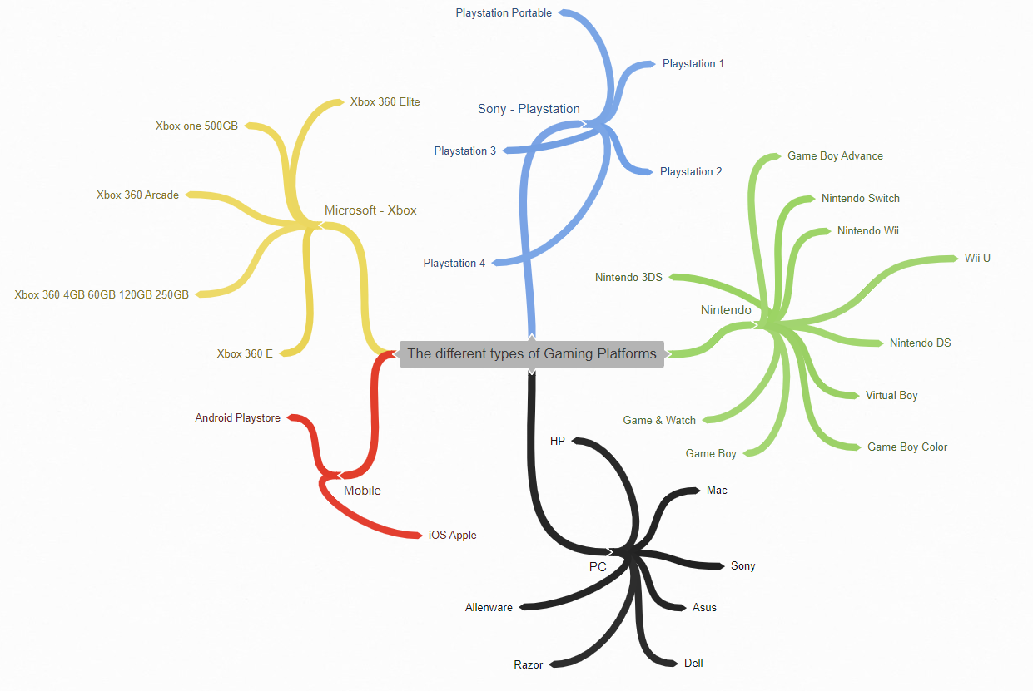

Gaming Platforms.

Mobile gaming applications, as illustrated in figure xx above, can be interfaced through two main avenues, either through the android app store, or IOS; our analysis is concerned with apps through the Apple IOS app store. Applications maintain inherent global accessibility through a globally connected framework, opening the doors to a customer base consisting of billions of users. This interconnectivity and broad customer base is not only beneficial for the app developers, but it also for the customer. This is due a low barrier of entry, simply requiring an internet connection, and a greater diversity in choice for the consumer.

In 2020, it was reported that revenue generated through mobile gaming accounted for nearly $70 billion, eclipsing all consoles and PC revenue, at $47.9 billion and $35.7 billion, respectively (Fig xx). Moreover, it is apparent that this trend continues into the foreseeable future, where NewZoo, an analytics firm that focuses on the gaming industry, notes that:

*Mobile gaming (smartphone and tablet combined) will produce revenues of $95.4 billion in 2022, growing with a CAGR of +11.3% to account for almost half (49%) of the entire games market. Revenues and growth will be driven predominantly by smartphones, with revenues of $79.7 billion by 2022 (a CAGR of +12.8%). Tablets will account for the remaining $15.7 billion, Emerging markets will contribute most to the segments growth. However, a range of other factors will also contribute, including more cross-platform titles, more smartphone users, and improvements in hardware and infrastructure (*[*https://newzoo.com/products/reports/global-games-market-report/*](https://newzoo.com/products/reports/global-games-market-report/)*).*

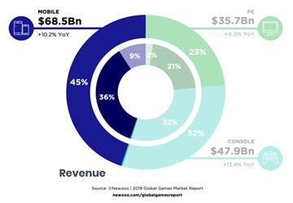

Revenue Per Platform.

Given this growth and dominance by mobile gaming platforms, our team has decided to construct an analysis that aims to further understand certain features that impact mobile gaming applications. We are intent on reviewing success as a factor of reviewer ratings, but also pricing, as it may negatively influence a customer’s decision to both use the application and rate it. We foresee that pricing can be used as a strategy by developers, where if they price the application low, they stand to increase user adoption, or if they price it high, they stand to decrease adoption, but increase their upfront revenue.

As part of our analysis we will be analyzing other quantitative variables available to us, like rating volume, average app rating, and the date in which the app was last updated. We will also review features and their possible implications on ratings, such as language, developer name, words used in the app name, the size of the application, the range that the game has been available, and the specified age rating. We postulate that by understanding how ratings in the mobile gaming market fluctuate on different parameters, we can determine key features that an app developer must focus on.

Our main objectives are as follows:

To check if multilinguality in an app affects its rating- A business spends a lot of money in developing apps in multiple languages with an aim of reaching a broader audience. Developing an app in multiple languages takes a lot of time and money. We wanted to check that if an app is made in multiple languages then is it rated any better or not. Also we wanted to check if multilinguality causes an app to be a good app or not.

To check if the updating of the app in the past 1 year affects its rating - From a business perspective the 2bd area where app makers/ businesses put a lot of money is into app updation with newer features. We wanted to check if app updation causes an app to be a good rated app or not.

To check if age rating of an app affects its rating - Apps are given ratings for the audience that is eligible to use it. Our initial hypothesis is that if an app is for adults only (rated 17+) than it is probable to have a lesser rating since it is reaching only a small segment of customers.

To check if the price of an app affects its rating - All kinds of apps are available in the market varying from ones completely free of cost to those ranging to $50 per month. We wanted to check if the price of an app has any effect on its rating.

# **Data & EDA**

Below we see the dataset used in this analysis. The data was scraped from the Apple app store by a third party where we then collected it through Kaggle, an online data science website. We note that there are 18 variables in total and 17007 applications.

|  |  |
| --- | --- |
| **MOBILE STRATEGY GAMES FEATURE OVERVIEW** | |
| **Feature** | **Feat. Desc.** |
| **ID** | The assigned ID |
| Name | The name |
| Subtitle | The secondary text under the name |
| Average User Rating | Rounded to nearest .5, requires at least 5 ratings |
| User Rating Count | No. of ratings internationally, null means it is below 5 |
| Price | Price in USD |
| In-app Purchases | Prices of available in-app purchases |
| Description | App description |
| Developer | App developer |
| Age Rating | Either 4+, 9+, 12+ or 17+ |
| Languages | ISO2A language codes |
| Size | Size of the app in bytes |
| Primary Genre | The main genre |
| Genres | Genres of the app |
| Original Release Date | Original Release Date |
| Current Version Release Date | Current Version Release Date |
| URL | The URL |
| Icon URL | 512px x 512px jpg |

## Initial EDA

#### **Descriptive statistics before data cleaning**:

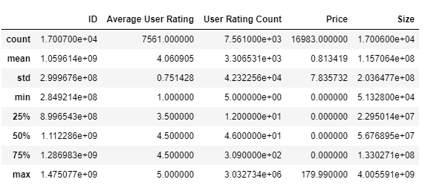

From the Average User Rating we see that 75% of the data has 4.5 rating, this means that the data is highly left skewed. User Rating count max value shows that there are outliers in the data. The price column also shows that 75% for the data has 0 price, this means that most of the apps are free and the data of the price is highly right skewed. The ID is an irrelevant column and hence we have removed it from the further analysis.

#### **Analysing Missing Values in Variables:**

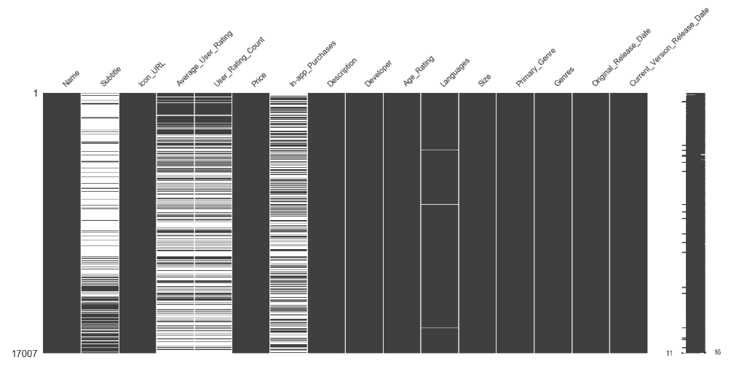

As we can see from the missing number matrix the following questions have significant missing values: Subtitle, Average_User_Rating, User_Rating_Count, In_App_Purchases columns. Our target variable is Average_User_Rating and if we were to replace the Average_User_Rating missing values with the mean then we would have got highly skewed data. Hence we decided on removing the missing values in Average_User_Rating for future Analysis.

#### **Extracting Icons for games on App store:**

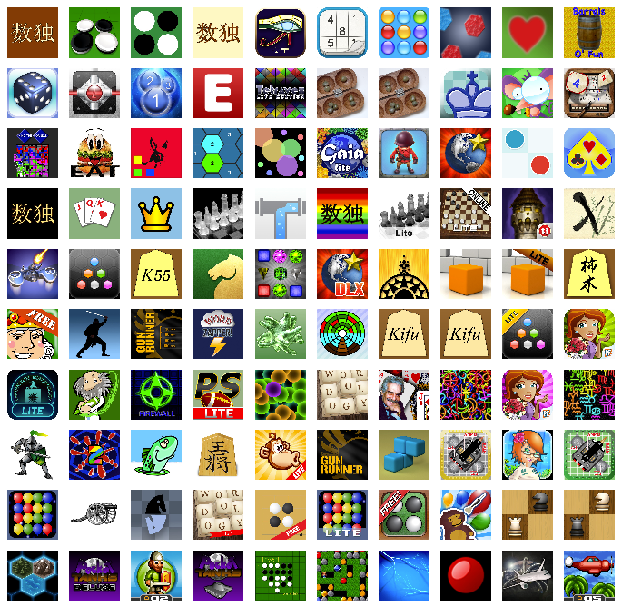

Just as a fun part of the EDA we extracted the Icons for the games listed from the Icon_URL. This helps us get the visual display of the games in the apple app store.

#### **Average User Rating Count:**

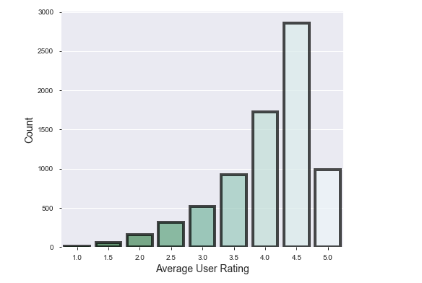

As we can see from the count plot, the users have mostly rated the apps in the range of 4.0 to 5.0 and maximum apps have a user rating of 4.5. The Average_User_Rating is highly left skewed.

#### **Correlation Plot for Genre List:**

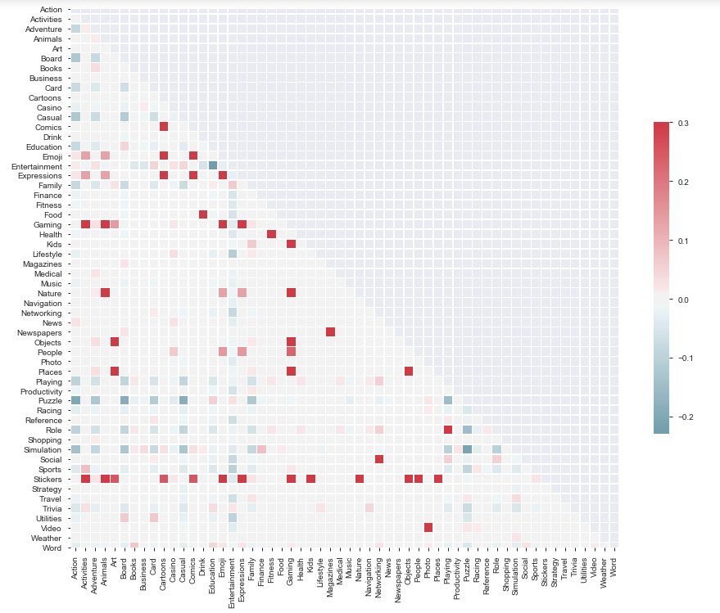

#### **Correlation Network Plot for Genre:**

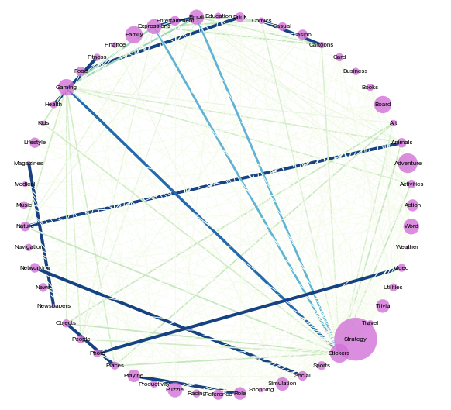

We had a Genre column which specified the genres an app belonged to. As we were analyzing the game data all the rows mentioned games as one of its Genre, we removed games and created a list of Genres the game belonged to. Then we created a correlation plot to analyse the correlation between different Genres. As we can see Stickers is highly correlated with cartoons, animals, activities, art etc. Next we created a graph of correlation plot using networkx. We only created a graph for positive correlation and weights on the edges suggest that strategy and sticker are linked to most other edges and have high positive correlation with them.

#### **Size and Average_User_Rating Analysis:**

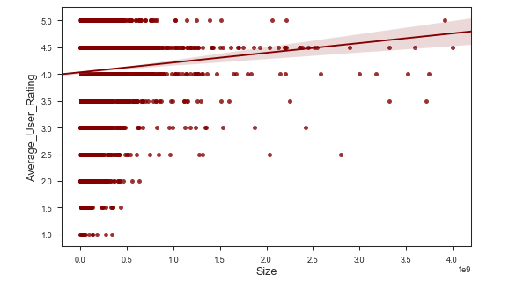

We plotted a regplot to find the relation between the size and the average_user_rating. We can see that there is a little positive correlation between size and average_user_rating. It means that as size increases, there are chances of apps being rated on a higher side.

#### **Size and Original_Release_Date Analysis:**

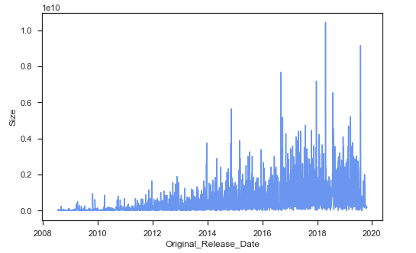

Our line plot indicates that the apps before 2014 were lower in size. The line plot also indicates that the newer the app the greater the size. This can also be deduced from the fact that post 2012 the I-phone captured the phone market so the number of games and sizes started increasing post that.

#### **App Price Analysis:**

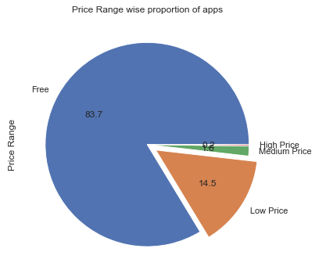

To analyse the prices of the app we created price ranges and plotted a pie plot. As most of the apps from our descriptive statistics were free we created four price ranges ie Free, Low Price ($0.99-$4.99), Medium Price ($5.99-$19.99) and High Price ($19.99 and above). This gives us a clear visibility that 83.7% apps are free apps. 14.5% apps are low priced apps and a very few apps fall in the higher ranges. For Price our hypothesis was lower the price, more likely is the app being rated.

#### **App Age-Rating Analysis:**

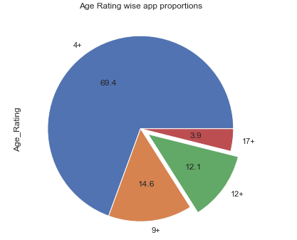

We plotted a pieplot to study the age ratings of the app. From the results we can see that almost 69.4% i.e. 70% of the games could be played by any age group and only 3.9% apps are adult apps. For age rating our hypothesis was that the older people are more likely to rate the app. Hence to restrict our analysis we decided to concentrate on the 17+ category for future analysis.

#### **Top 10 Languages:**

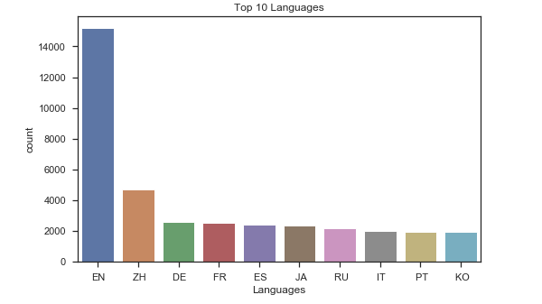

We plotted a count plot for the languages an app is available in. From the plot we can see that almost all the game apps that are available on the apple app store are in English, followed by Chinese and then the other languages. To analyse the effect of languages on the user-ratings our assumption was that the more the number of languages the app is available in, the higher the chances of it being rated high.

## 

#### **Most Reviewed & Popular Games:**

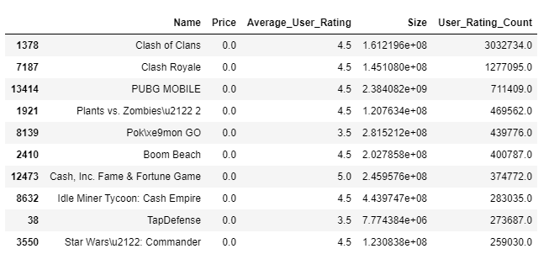



We wanted to check the most reviewed and popular games.One great insight from this is that all the top 10 most reviewed and popular games are all free. They all have higher user ratings except for PokemonGo and TapDefence. We have also extracted icons for the top 3 games. The Top 2 most popular games are from the same game company ie Supercell.

#### **Best Overall Game in App Store**

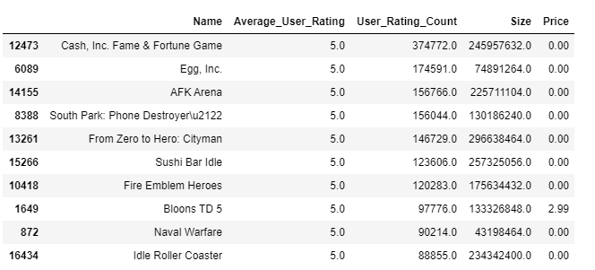

We wanted to check the best overall game in the Appstore. One great insight from this is that all the top 10 most highly rated apps is that all the high rated apps don't have a higher user rating count. The Best overall game in the app store is the Cash, Inc Fame & Fortune Game. We have also extracted the icon of this best overall game on App store ie with highest user rating, high user rating count and free app.



#### **Wordcloud of Name:**

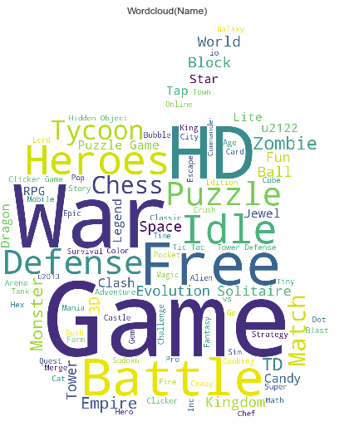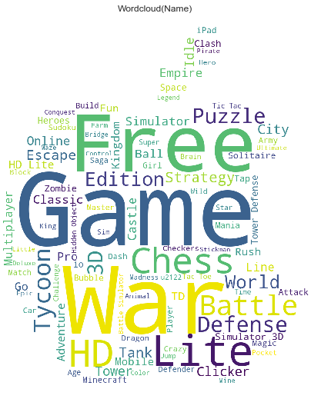

Lastly we plotted a word cloud of the name column for average_user_rating > 4 and average_user_rating< 4 to check if some word in the name of the game makes it popular to get a higher overall rating. The left word cloud is for average_user_rating > 4 and the right one is for average_user_rating < 4. We see that for user rating > 4 popular words are HD, Heroes, Puzzle, Battle, Defence as against for average_user_rating < 4 we see that Free, Game and Lite are the most popular words . Hence we can also say that words might also play an important role in determining user ratings.

## **Data Cleaning, Manipulation & Post EDA**

In our analysis we constructed a binary dependent variable from the average user app rating variable. Since we are analyzing the inferred success of an application, app rating is the best available variable. After reviewing the data, we find that 9446 applications are without an average user rating –the figure on the right illustrates this. In our case, since this data is not available and we wanted to narrow down the influence of noise or indirect inference, we decided to only include apps that have had time to gain user ratings, dropping those that don’t.

The remainder of the data maintains ratings between the value of 1 through 5, with increments of 0.5 between. The lowest rating is noted as 1, with 5 being the highest. The median rating score is 4.5, with a mean of 4.0. This indicates that the rating is skewed, as is normal for ratings. From here we decided to split good and bad applications, maintaining that applications with a rating of 4.5 or above, have good ratings, and all values below are categorized as apps with a bad rating. In the illustrations below, we can see the distribution and the proportion of these applications. This proportion is balanced, leaving 3851 applications with a good rating, and 3710 as bad.

|  |  |
| --- | --- |
|  |  |

After separating the rating into two clear segments based on the rating score, we further reviewed certain variables in how they pertain to each category. Looking first at pricing, we found that there are even and overlapping distributions (As we will see with version updates, these distributions differ). The pricing distributions are similar, leaving a total of 3053 apps with a bad rating and 3272 with a good rating. Across each price per rating, from $0.99 to $179.00, the frequency counts are also nearly identical, with an exact match at $2.99, $7.99, and $9.99. This provides us with the insight that not only does price not vary much within the whole dataset, but also between apps with a good and bad rating. Additionally, a large proportion of the prices for apps are zero. This number is 6325 of zero priced apps out of the 7561 total apps; 83.7% are zero. The remaining 16.3 % share pricing from $0.99 to $179.00.

From pricing, we move onto reviewing two similar variables and their relation to game app ratings. Looking at the histograms below, we see days since the app was last updated, along with a graph of the total number of days an app has been in the app store; this is labeled as tenure. These day counts are split further by the binary dependent variable, rating, and placed in overlapping distributions. This method helps illustrate any differences between the two groupings. Unlike pricing, there is a difference. It is apparent that as the total days that an app has been on the market approaches 1000 days, then a higher proportion of those apps begin to receive a bad rating. The opposite is true in the other direction; the less days an app is on the market, then there is a higher proportion of good rated apps.

We see a similar pattern in the days since the last update was released. It is clear that apps that have not been updated within the last 1000 days are rated proportionately bad versus those with an update above within that period. After further categorizing the days into years, we clearly see that there is no break in the trend, year-over-year.

|  |  |
| --- | --- |
|  |  |
|  |  |

We further manipulated the variables for language and for age rating, where these visualizations can be seen in the initial EDA. From here we will substantiate the variables and their connection to rating through a combination of two modelling methods, logistic regressions and propensity score matching.

# **Modelling**

## **Premodeling**

To do our analysis we did some feature engineering and created following variables:

* **Tenure** - this is the amount of time the app has been on the play store. It was calculated by subtracting the original release date from the date this app data was taken out of apple play store i.e. 3rd August 2019.
* **Days_since_last_release** - this is the amount of time elapsed before the app was last updated. It was calculated by subtracting the current version release date from the date of extraction of the app-data from Apple play store.
* **Adult** - this was a binary variable which signified if the app was an adult rated app or was open for all age-groups. The apps with app rating 17+ were rated as Adult and had Adult variable set to 1, rest all the apps had the adult variable set to 0.
* **Lang_count-** this variable tells the no of languages an app is available in.
* **Rating** - the rating variable was made binary for further analysis. The apps with a rating greater than 4 were rated as good and had rating being set to 1 and the others were rated as bad with the rating variable being set as 0.
* **Mean_in_app_purchase** - This represented the mean price of the in app commodities available in the app.
* **Sum_in_app_purchase** - This represented the maximum possible revenue an app can make from a customer from its in app commodities.

## **Propensity & Logistic Regression**

For checking the effect of the said variables price, age, language and appupdation on rating, we ran a logistics regression model on the cleaned data. Below is the result of this model. As can be seen for price the p value (greater than 0.01) indicates that at 1% significance we cannot reject the null hypothesis i.e the relationship between price and rating is statistically insignificant. This corroborates our findings during our initial exploratory data analysis as discussed above.

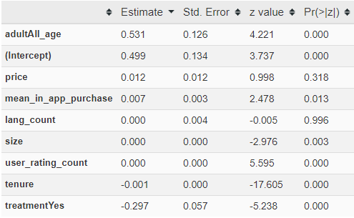

#### **Propensity Score Matching - Multiple Languages**

To check if multilinguality in an app causes the rating to be good, we first created a treatment variable on language count. Apps which were developed in more than 1 language (i.e lang_count>1) fall in the treatment group and have treatment being set as 1. Apps which were developed in only 1 language fall in the control group and have treatment being set as 0. We then performed a propensity score matching procedure completely matching the treatment group and control group on all the variables except for rating. Below is the result of this procedure.

**T-test on unmatched data for rating**

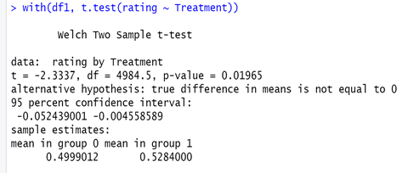

For unmatched data, at 1% significance level (p-value almost equal to 0.01) we can say that for the treatment group where the apps were developed in more languages have got a better rating as compared to apps developed in only 1 language ( control group) .

After performing the propensity score matching procedure on this data matching all the variables except for rating for treatment group and control group we got below distribution .

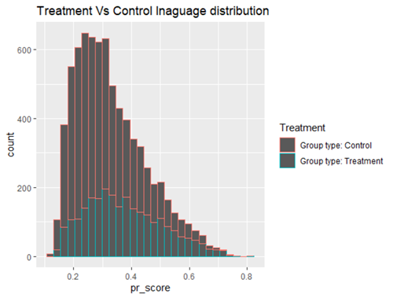

As can be seen in the graph above, the distribution of propensity score for treatment and control group is pretty similar indicating that the data was properly matched. The same was checked by conducting T-test for all the variables between treatment group and control group. In the appendix, we can see the result of this T-test. The p-value of T-Tests for all the variables are greater than 0.01, indicating that at 1% significance we had to accept the null hypothesis, meaning the variables had the same value for the treatment group and control group. Looking below at the graphs of matched data for each and every variable, the lines are overlapping for the treatment group and control group, confirming that the data is fully matched.

|  |
| --- |
| **Matched Data Covariate Overlap, Language** |

Conducting a t-test on the matched data to see if the Treatment (that is multilinguality in app) causes the rating to be any better or not.

|  |
| --- |
| **T-Test Matched Data, Language** |
|  |

At 1% significance level, p value equal to ~0.026 indicates that the null hypothesis cannot be rejected. Therefore the mean rating of multilingual apps and single language apps are the same. In other words, the difference in their rating is statistically insignificant. This means that developing an app into multiple languages with an aim of improving rating is not recommended and the business should not spend a lot of money on this.

#### **Propensity Score Matching - 1- Year Updates**

We move onto reviewing the implications of app updates on the review rating. To check if an app updated in the past 1 year causes the rating to be good, we first created a treatment variable on days_since_last_release. Apps which had a release being made in the past 1 year (i.e days_since_last_release < 365) fall in the treatment group and have treatment being set as 1. Apps which did not have any release in the past 1 year fall in the control group and have treatment being set as 0. We then performed a propensity score matching procedure completely matching the treatment group and control group on all the variables except for rating. Below is the result of this procedure.

**T-Test Unmatched Data, 1-Year Update**

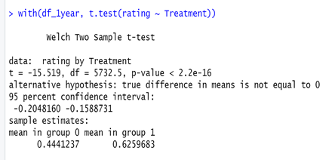

For unmatched data, at 1% significance level (p value less than 0.01) we can say that the treatment group, or the apps updated in the past 1 year have got a better rating as compared to apps not being updated in the same span (control group) .

After performing the propensity score matching procedure on this data matching all the variables except for rating for treatment group and control group we got the below distribution. This distribution is notably good, since there is consistency when comparing the distribution of the control group to the treatment group.

|  |
| --- |
| **Matching Distribution** |
|  |

As can be seen in the graph above, the distribution of propensity score for treatment and control group is pretty similar indicating that the data was properly matched. The same was checked by conducting a T-test for all the variables between treatment group and control group. In the appendix, we can see the result of this T-Test. Looking at the p-value of T-Test for all the variables, it is greater than 0.01 indicating that at 1% significance we had to accept the null hypothesis. This means that the variables had the same value for the treatment group and control group. The same can also be seen in the graph of matched data for each and every variable, the lines are overlapping for the treatment group and control group confirming that the data is fully matched. This can be seen below.

|  |
| --- |
| **Matched Data Covariate Overlap, 1-Year** |
|  |

Conducting a t-test on the matched data to see if the Treatment (that is app updation in past 1 year) causes the rating to be any better or not.

**T-Test Matched, 1-Year Update**

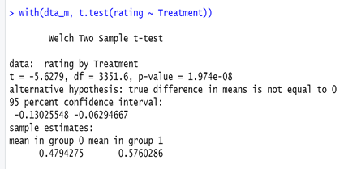

At 1% significance level, the p value is less than 0.01, indicating that the null hypothesis can be rejected. Therefore the mean rating of apps updated in the past 1 year is significantly different from those not updated in the same span, in other words the difference in their rating is statistically significant.

To see the extent of the effect of treatment i.e app updation in the past 1 year on the rating of the app, we conducted a logistics regression on the matched data with rating as dependent variable and price, language,age etc as independent variables. For both price and language, the p-value was greater than 0.01 indicating that their relationship with rating is insignificant at 1% significance level.

We reran the model with the significant variables Treatment (Binary- App updation in past 1 year yes =1, no=0), user rating count = No of users who rated the app, size = size of the app, tenure (time on app store), Adult (available only for 17+ ), where below we can see this logistic regression result.

|  |
| --- |
| **Logistic Model, Treatment & Covaries on Rating** |

Lastly, we finalized this last model by taking the exponent of the coefficients. From this, we can deduce the following relationship between our dependent variable rating and independent variables in discussion, i.e. app updation in past 1 year (Treatment) and Adult (app being rated as 17+ ):

* The odds of an app being rated as a good app increases by 47.2% if the app was updated in the past 1 year.
* The odds of an app being rated as a good app decreases by 37% if the app has got an age rating of “17+”(Adult =1)

|  |
| --- |
| **Taking the exponent of coefficients to interpret the odd ration** |

# **Conclusion**

Our analysis focused on analyzing app ratings in context to price, age rating, language availability, and update frequency. We discovered through an initial analysis that price is not a significant factor on app rating. This is mainly due the variance in price ranges and the disproportionate number of prices with a zero. This was noted as approximately 84% of the price data, with the remainder of pricing split between 18 other price ranges. After running logistic regression with the rating set as a dependent variable, we further confirmed that there is not significance on rating.

Along with price, we analyzed apps that include multiple languages, noting that if an app is restricted one language versus one that is accessible through multiple languages, then the app with more languages should be expected to have a better rating. We did not find this to be the case. In fact, we found that language has no significant impact on the rating of an app. This is further proven through propensity score matching where apps with more than one language were used as treatment. Here we see there is no significant difference between a sample population that has received the treatment of using an app with multiple languages versus those that have not.

Lastly, we have user age rating and app update frequency. We do find that these variables have a significant impact on the app rating. Most notable of these is the update frequency. As found in the initial variable analysis, there is a strong correlation between good apps and how recent they have been updated. Moreover, our analysis shows that the odds of an app being rated a good app are increased by 47.2% if it has been updated within the past year. Within this same test, we see that if age is restricted to the seventeen plus age group and above, then there is a 37% decrease in the odds that the app will receive a good rating.

A final note of the implications for app developers would be to focus on improving their applications through continuous yearly updates, yet it is not imperative that they develop language packs, since there is little value in terms of getting a good rating.

# **Dataset Overview**

|  |  |  |
| --- | --- | --- |
| **Dataset: Mobile Strategy Applications** | | |
| **Data Dimensions** | [17008 x 18]: 17008 Observations & 18 Features | |
| **Source** | https://www.kaggle.com/tristan581/17k-apple-app-store-strategy-games |  |
| |  |  | | --- | --- | | **MOBILE STRATEGY GAMES FEATURE OVERVIEW** | | | **Feature** | **Feat. Desc.** | | **ID** | The assigned ID | | **Name** | The name | | **Subtitle** | The secondary text under the name | | **Average User Rating** | Rounded to nearest .5, requires at least 5 ratings | | **User Rating Count** | No. of ratings internationally, null means it is below 5 | | **Price** | Price in USD | | **In-app Purchases** | Prices of available in-app purchases | | **Description** | App description | | **Developer** | App developer | | **Age Rating** | Either 4+, 9+, 12+ or 17+ | | **Languages** | ISO2A language codes | | **Size** | Size of the app in bytes | | **Primary Genre** | The main genre | | **Genres** | Genres of the app | | **Original Release Date** | Original Release Date | | **Current Version Release Date** | Current Version Release Date | | **URL** | The URL | | **Icon URL** | 512px x 512px jpg | | |  |

# **Additional Figures and Results**

|  |  |
| --- | --- |
| **Average User Rating > 4** | **Average User Rating < 4** |
|  |  |

|  |
| --- |
| **Size Density Graph** |
|  |

|  |
| --- |
| **NLP - Bigrams & Trigrams** |
|  |
|  |

|  |
| --- |
| **Updating Effect** |
|  |

|  |
| --- |
| **Top 20 Game Languages** |
|  |
|  |

|  |  |  |  |  |
| --- | --- | --- | --- | --- |
| **Logistic | Rating Good** | | | | |
|  | **Estimate** | **Std. Error** | **z value** | **Pr(>|z|)** |
| **(Rating > 4.0 = Good))** | 0.458 | 0.133 | 3.434 | 0.001 |
| **adultAll_age** | 0.541 | 0.126 | 4.304 | **0.000** |
| **mean_in_app_purchase** | 0.006 | 0.003 | 2.200 | 0.**028** |
| **price** | 0.002 | 0.010 | 0.180 | 0.**857** |
| **tenure** | 0.000 | 0.000 | -13.053 | 0.000 |
| **days_since_last_release** | 0.000 | 0.000 | -8.147 | 0.000 |
| **size** | 0.000 | 0.000 | -3.210 | 0.001 |
| **user_rating_count** | 0.000 | 0.000 | 5.198 | 0.**000** |
| **lang_count** | -0.001 | 0.004 | -0.361 | 0.**718** |

|  |
| --- |
| **Propensity – Multilingual | TTest Covariates** |
|  |
|  |

|  |
| --- |
| **Propensity - Recent 1-Year Updates | TTest Covariates** |
|  |
|  |